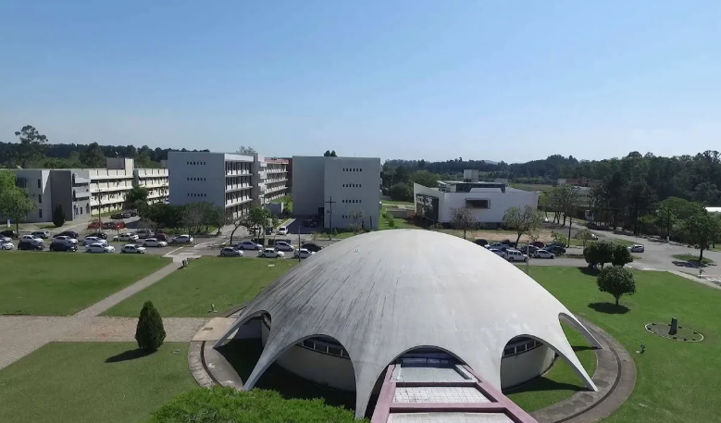

Federal University Santa Maria (UFSM)

